***Introduction to Power BI***

“Understanding the Fundamentals and Workflow of Power BI”

Created by: **Vaishak V V**

Date: **30/11/2024**

Course: **Power BI Basics to Advanced**

Table of Contents

**1.What is Power BI** 2

Definition: 3

Core Features: 3

Diagram/Visual: 3

**2. Why Learn Power BI?** 3

Relevance in Careers: 3

Key Benefits: 3

Real-Life Examples: 3

**3. Power BI Ecosystem Overview** 4

Power BI Desktop: 4

Power BI Service: 4

Power BI Mobile App: 4

Power BI Gateways: 4

**4. Power BI Workflow** 4

Step 1: Connect to Data: 4

Step 2: Transform Data: 4

Step 3: Model Data: 4

Step 4: Visualize Data: 4

Step 5: Publish and Share: 4

**5. Real-World Use Cases** 4

Sales Analysis: 4

Marketing Campaigns: 4

Finance: 4

Healthcare: 4

Customer Support: **Error! Bookmark not defined.**

**6. Activities and Homework** 5

Activity 1: Reflection: 5

Homework: 5

# **1.What is Power BI**

## Definition:

* Power BI is a business analytics tool by Microsoft that allows users to visualize data, share insights, and create interactive reports and dashboards.
* Example: Imagine analysing sales data in a graphical format instead of spreadsheets.

## Core Features:

* Data Visualization: Charts, graphs, and reports.
* Integration: Connects to various data sources like Excel, SQL, and online services.
* Accessibility: Accessible on desktops, mobile devices, and the web.

## Diagram/Visual:

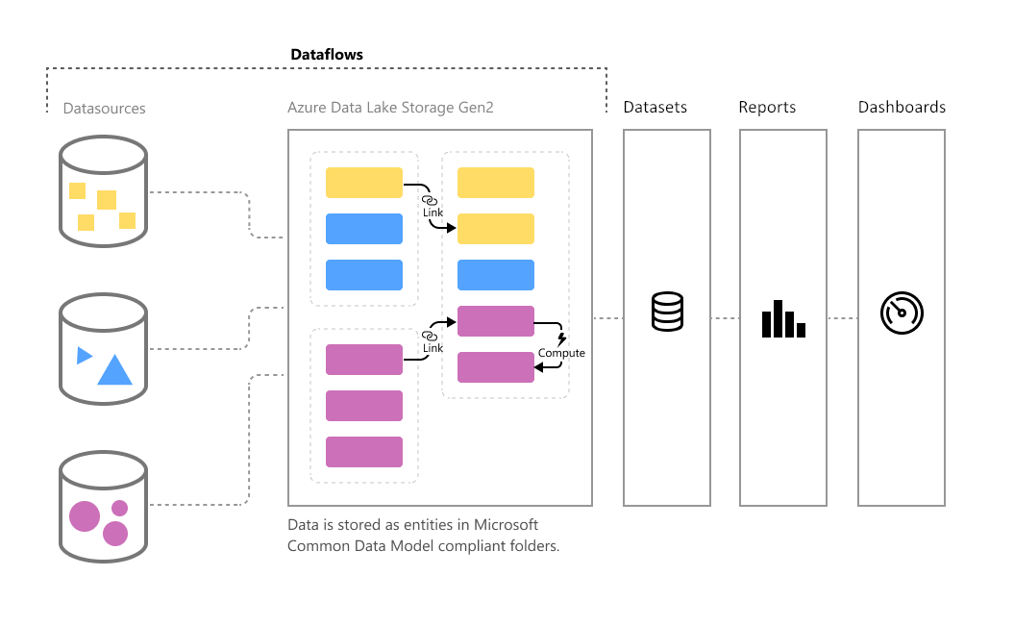

Figure : Overview of the Power BI Workflow – Raw Data to Visual Insights.

"This diagram illustrates the Power BI workflow. It begins with importing raw data from various sources, which is then transformed and modelled in Power BI. Finally, the cleaned data is visualized in reports and dashboards, providing actionable insights."

# **2. Why Learn Power BI?**

## Relevance in Careers:

* Used by businesses worldwide for data-driven decision-making.
* High demand in roles like data analysts, business analysts, and project managers.

Key Benefits:

* Saves time with automation.
* Easy to use for both technical and non-technical users.
* Builds professional-looking dashboards and reports.

Real-Life Examples:

* An HR department uses Power BI to analyse employee productivity.
* A marketing team tracks campaign performance through interactive dashboards.

# **3. Power BI Ecosystem Overview**

## Power BI Desktop:

* Where you create reports and dashboards.
* Key tools: Data modeling, DAX, and visualization tools.

## Power BI Service:

* A cloud-based platform for sharing and collaboration.
* Example: Share a sales performance report with your team online.

## Power BI Mobile App:

* Access reports and dashboards on-the-go.

## Power BI Gateways:

* Connects on-premise data to Power BI.

# **4. Power BI Workflow**

## Step 1: Connect to Data:

* + Import data from Excel, databases, or online services.

## Step 2: Transform Data:

* + Use Power Query Editor to clean and prepare the data (e.g., remove duplicates).

## Step 3: Model Data:

* + Define relationships between tables for analysis.

## Step 4: Visualize Data:

* + Create interactive visuals like charts, tables, and KPIs.

## Step 5: Publish and Share:

* + Publish reports to the Power BI Service and share with others.

# **5. Real-World Use Cases**

## Sales Analysis:

* Visualize sales trends, compare regions, and track key metrics.

## Marketing Campaigns:

* Measure the effectiveness of campaigns using dashboards.

## Finance:

* Create financial performance reports and predict trends.

## Healthcare:

* Analyse patient data and optimize resources.

# **6. Activities and Homework**

## Activity 1: Reflection:

* Write down what you learned about Power BI today.

## Homework:

* Research online: “Top 5 companies using Power BI and how they use it.”
* Write a short paragraph about the benefits Power BI offers to businesses